GRADE | 10 | SUBJECT |  | CAT |  | WEEK |  | W3  L1 |  | TOPIC | Solution Development: Word Processing –Paragraph Basics- Bullets and Numbering
LESSON SUMMARY FOR:
DATE STARTED |  |  |  |  |  |  | DATE COMPLETED
LESSON OBJECTIVES |  |  | At the end of this lesson the learner must be able to:  - Know how to structure documents using Bullets and Numbering
TEACHER ACTIVITIES |  |  |  |  |  |  |  |  | LEARNER ACTIVITIES |  |  |  | TIMING | RESOURCES NEEDED
1. Methodology  - Hands On lesson  - Power point presentation  - Text book  2. Introduction  Introduce learners to:  - What is a Bullet  Bullets: A bullet is a character, often a small circle that appears before the items in a list to add emphasis.  What about Numbering?  Formatting a numbered list helps illustrate sequence and priorities.  3. Main Body (Lesson presentation)  To access / apply a list with bullets and numbering click on  the Bullets and Numbering button in the paragraph group on  the Home tab.  By default, if you start a paragraph with an asterisk or a number 1. Word recognizes that you are trying to start a bulleted or numbered list.  - .  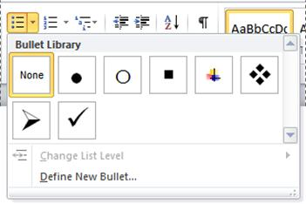  - Format bullets or numbers:  To format bullets or numbers differently from the text in a list.  For example, click a number and change the number colour for  the entire list, without making changes to the text in the list.  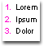  - Use pictures or symbols: Create a picture bulleted list to add  - Visual interest to a document or a Web page.    Create a one-level bulleted or numbered list  Word can automatically create bulleted and numbered lists as you type, or you can quickly add bullets or numbers to existing lines of text.  Type a bulleted or numbered list  - Type * (asterisk) to start a bulleted list or 1. To start a numbered list, and then press SPACEBAR or the TAB key.  - Type any text that you want.  - Press ENTER to add the next list item.  Word automatically inserts the next bullet or number.  - To finish the list, press ENTER twice, or press BACKSPACE to  delete the last bullet or number in the list. If bullets and  numbering do not begin automatically  - Click the File tab and then click Options.  - Click Proofing.  - Click AutoCorrect Options, and then click the AutoFormat as  You Type tab.  - Under Apply as you type, select the Automatic bulleted  lists check box and the Automatic numbered lists check box.  Add bullets or numbering to a list  - Select the items that you want to add bullets or numbering to.  - On the Home tab, in the Paragraph group,  click Bullets or Numbering.  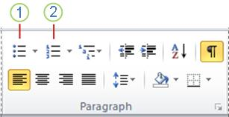  Create a List from Existing Text:  Following are the simple steps to create either bulleted list or numbered list.  Step 1: Select a list of text to which you want to assign bullets or numbers. You can use any of the text selection method to select the text.  Step 2: Click the Bullet Button triangle to display a list of bullets you want to assign to the list. You can select any of the bullet style available by simply clicking over it.  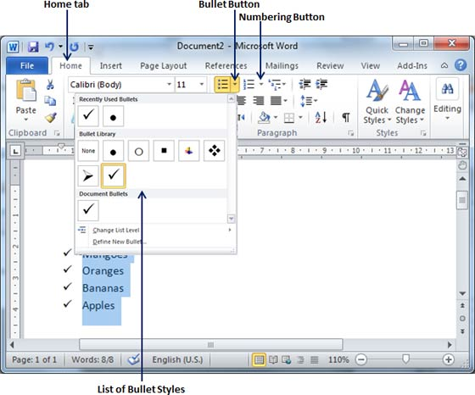  Step 3: If you are willing to create a list with numbers then click he Numbering Button triangle instead of bullet button to display a list of numbers you want to assign to the list. You can select any of the numbering style available by simply clicking over it.  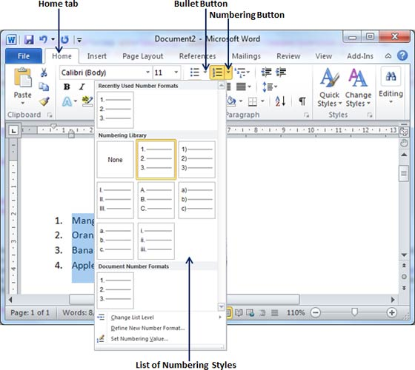  Create a List as You Type:  You can create a bulleted list as you type. Word will automatically format it according to your text. Following are the simple steps to create bulleted list as you type.  Step 1: Type *, and then either press the SPACEBAR or press TAB key, and then type the rest of what you want in the first item of the bulleted list.  Step 2: When you are done with typing, press Enter to add the item in the list automatically and go to add next item in the list.  Step 3: Repeat Step 2 for each list item.  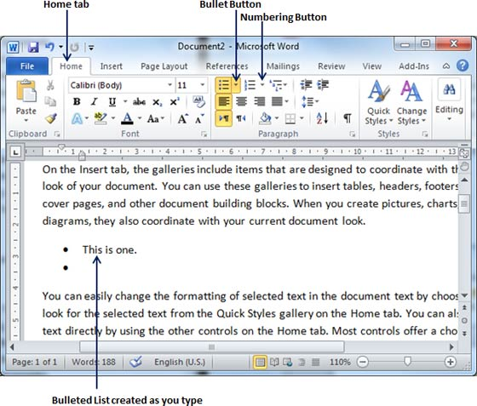  Or press TAB key, and then type the rest of what you want in the first item of the numbered list.  Step (2): When you are done with typing, press Enter to add the item in the list automatically and go to add next item in the list.  Step 3: Repeat Step 2 for each list item.  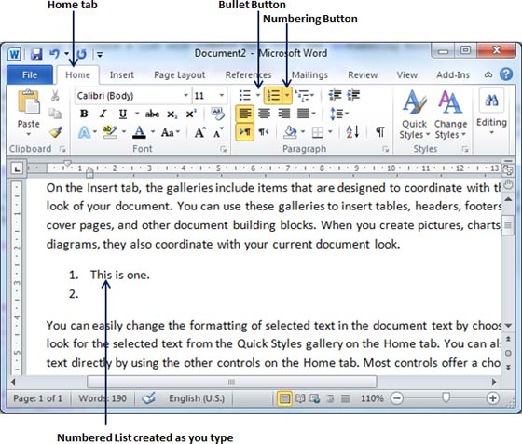  Source:  http://office.microsoft.com/  http://www.tutorialspoint.com/word_2010/  http://helpdeskgeek.com/office  4. Conclusion  Bullets and numbering add value to presentation and readability  PRACTICE! PRACTICE! AND Practice!!!! For perfection. |  |  |  |  |  |  |  |  | Before learners attempt the activities let them practice on the document Guideline to learner in the Resources folder  Folder DataFiles_Solutions for learners to practice  Computers  Part of your Life  p. 213 Act 1  Via Afrika  p.135 Act 19 |  |  |  | Introduction and definition 10 minutes  The rest of the time allocated on explanation of the lesson | PowerPoint presentation  Data projector  Other Resources Folder  Prescribed Textbooks  Computers  Part of your Life  p. 212-213  Via Afrika  p.134-135  Focus  p. 228-229

Name of Teacher: HOD:
Sign: Sign:
Date::______________________________________ Date:

